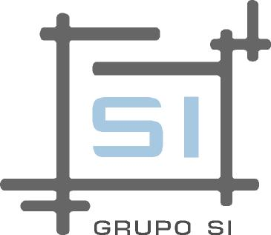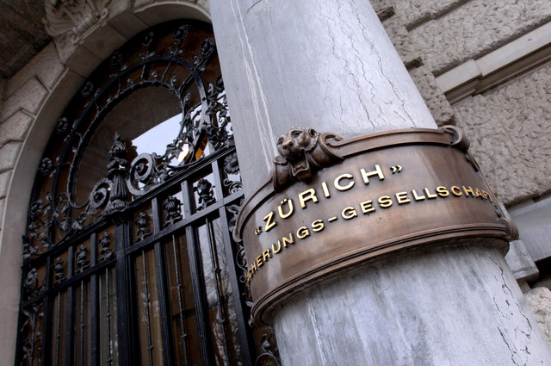

Global Solution for the complete transfer of Santander’s insurance business unit to Zurich.

By early 2012, Zurich Insurance Group negotiates with Santander Bank the buying of their insurance business unit. Once the operation is completed, Zurich meets an immense task: the migration of all equipment, data, systems, customers and human resources from Santander's infrastructure to its headquarters. The main goal was to carry out the process without affecting the operation of Santander Insurance existing businesses, by then part of Zurich Insurance Group, and continuing with the objectives of their portfolio’s expansion.

.

**Region: Europe & Latin America**

**Sector:** Financial   
Services

**Client profile: Zurich** is a financial services company whose headquarters are located in Switzerland. It has more than 60.000 employees who provide solutions to 38 million customers in 170 countries. In this project, was involved specifically the business unit Zurich Insurance Group.

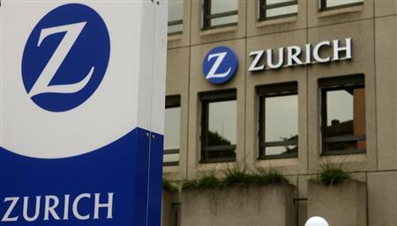

**A comprehensive migration: the need of including all resources.**

Due to the project size, Zurich decided to outsource the total migration in a supplier. This last needed to be able to meet the high demands of the objectives to be achieved in the limited time available. At the time of presentation, there was a special emphasis on the need for a comprehensive survey by the supplier in question, including all the resources affected by the process. **Zurich** selected **FullTech365**, who had been already working for more than a year for this client, providing reports of the behavior patterns of more than 4000 employees in 6 countries in Latin America.

Based on the specific objectives, **FullTech365** assigns a Project Manager to start the survey. The initial phase consisted of 20 users, each with their own data, equipment and customers, and **FullTech365** should propose a method to achieve the moving of all that package to Zurich Insurance Group. It is at that point which the first barrier is found: how to connect people located in Santander’s offices throughout Latin America and Spain, to systems located in the offices of Zurich Switzerland, without compromising the security of the network infrastructure of both parts.

Working both as a broker, coordinator and technical team, **FullTech365’s** team completed in the first three months of the project, working together with Santander’s and Zurich’s technical teams, the successful migration of the first group of users. The starting point was the total implementation of a new Citrix platform, from installation and configuration of the servers, the creation of a whole user structure and its management, to allow outgoing connection to client computers. This last was the key: there was necessary changing firewall settings and resource permissions that differed at each site and country.

Convinced by the success of the first phase, Zurich Insurance Group assigned to **FullTech365** the second part of the project, which eventually was developed more efficiently, making the total passage of 100 more users in just 3 months.

**The ability to build the road.**

Since the beginning of the project, **FullTech365** faced with the need to provide a differential solution. There was no previous model, there was nothing similar. We had to build the road as we went along. The big challenge was to achieve the interconnection of the network infrastructure of both parties involved, allowing access from each one of them to the existing systems in the other, according to the regulations and safety measures already established. Based on this, **FullTech365** worked with Santander’s and Zurich’s technical teams from Brazil, Argentina, Uruguay, Mexico, Chile, Venezuela, Spain, and Switzerland, and managed the successful installation and implementation of the procedures developed and proposed specifically for the project.

The results of the first stage were obvious: everything was working within the proposed times, the passage had been more than ordered. Zurich Insurance Group took this step as an evaluation method, and the results concluded in the continuity of **FullTech365** as the selected provider for the project.

***“We knew it was not easy, we knew it was no quick… what we didn’t know was how to do it. FullTech365’s team developed, without breaking our timelines, all the necessary tools according to our needing. We saw that at the first phase, what definitely decided us to continue working with this partner.”***

**Karsten Necke  
Head up of the project  
Zurich Insurance Group Switzerland**

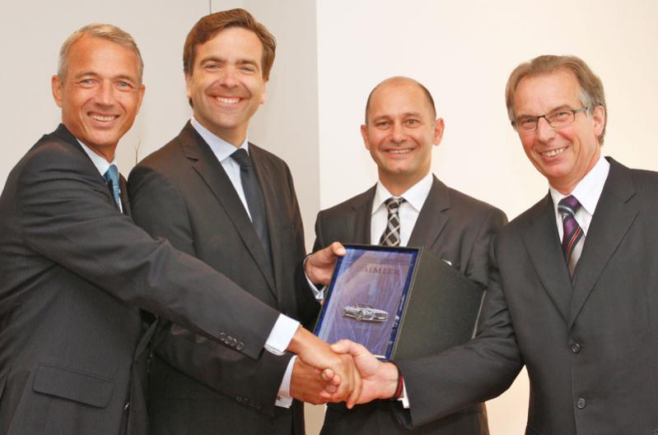Thanks to **FullTech365**’s work, Zurich Insurance Group was able to complete in a timely manner the immense movement of resources. We worked within the time originally stipulated by the customer, and developed tools that concluded with a decrease in migration costs and subsequent maintenance of the new area. In addition, **FullTech365** instructed Zurich’s Help Desk to allow them to provide all the necessary post-migration support, achieving compliance with the expected response.