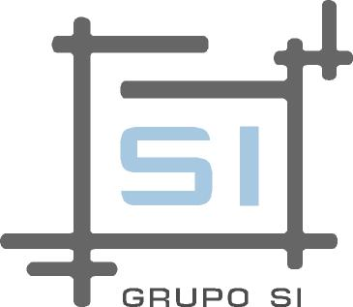

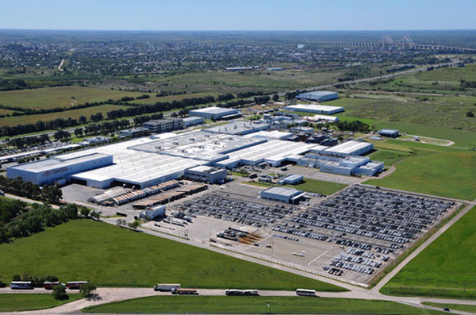

Zarate Factory – Toyota Argentina – Help Desk Service Implementation.

Toyota Argentina was looking for a supplier with the necessary experience and resources to work in the project of expansion and restructuring of the IT support service. Historically, those tasks were accomplished by a limited number of employees, which offered Helpdesk services within a time slot shorter than the total time of plant activities.

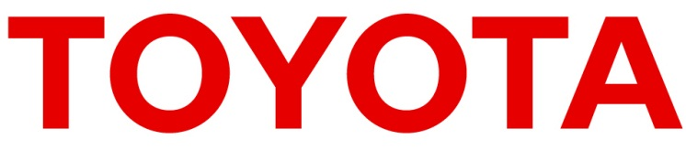

Based on that, the company presents his situation to **FullTech365**, and puts special emphasis on the need of a comprehensive restructuring that would allow the current service, then overflowed, mutate to the level needed to cover all the usual requirements of everyday

**Region:** Argentina

**Sector:** Automotive

**Client Profile: Toyota Motor Corporation** is a Japanese company which works with the highest quality standards. In Argentina, it’s characterized by the production of vehicles with wide acceptance and use in rural areas, and by the quality of their after-sales services.

**The need of a change and the ability to face it.**

When Toyota Argentina contacts **FullTech365**, the IT support service was widely overflowed: the Help Desk consisted of 3 people and a part-time coordinator, who shared his responsibility with other tasks, to meet 600 end users, on-site and remote.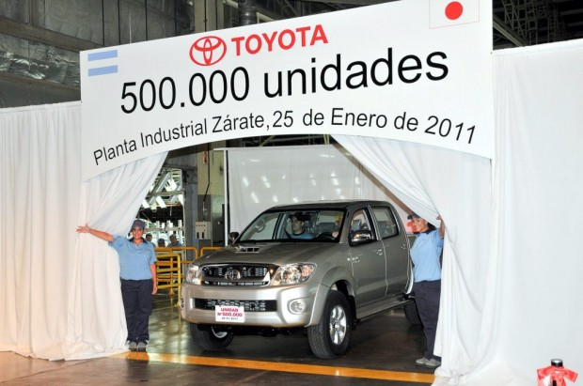

When taking the responsibility to provide the Help Desk service at Toyota Argentina offices, **FullTech365** completely restructured the way the support was given. From the beginning of the process, the Service Desk grew on requirements, users and assigned technicians.

We defined a service with qualified and trained personnel to fill the time slot from 6:00 to 1:00 on weekdays, and from 6:00 to 15:00 on Saturdays. During the nine years of service, there was not a single day in which the technical support was not given, including days with problems on personnel transportation to access Zarate plant.

With FullTech365’s management, the Help Desk became the first contact point for any technical issue. We worked conscientiously with technicians to ensure that all incidents were loaded in our own ticket management system, what allowed eventually manage them and meet the SLA times. Consequently, we created a knowledge base of common issues, allowing us to work both corrective and preventive maintenance.  
The level of end user satisfaction was growing since **FullTech365** began the service implementation. Applying personalized standards and procedures for our customer, and finally reaching a high point of compliance.

In addition to daily tasks, there were taken from the Help Desk countless specific projects, including the migration of 650 PC's. Such equipment was replaced meeting a demanding schedule and short response times, always considering that the task had to be as transparent as possible for the end user, avoiding any impact on the plant productivity.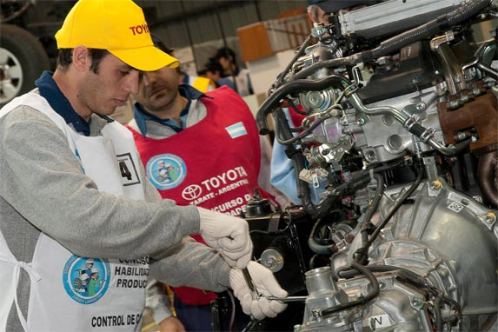  
Currently, Toyota Argentina Help Desk Service serves more than 1,000 users in every company location, with our own staff and management software.

**Following the correct path: the search of the optimal result.**

When **FullTech365’s** participation was defined as Service Desk Project provider, the need of a deep restructure was detected. The existing resources were overstretched, and this was not reflected in the reports presented every month. We had to fulfill a dual role: increase resources assigned to support tasks and, at the same time, show that the enlargement was really necessary. We had to instruct the company as a whole in the use of the Help Desk. Until then, the prevailing attitude was that users go directly to the specialized resource to solve a problem, without going through the Help Desk as an institution and, therefore, without performing any record of the task. This required great efforts by all **FullTech365’s** staff, but was reflected in the numbers in less than 90 days.

***“Before incorporating FullTech365 as our partner, we had a very limited support structure. The production plant grows continuously, increasing the number of users and therefore the amount of requests and incidents. FullTech365’s flexibility to adapt to changes and satellite projects was essential to meet our requirements”***

**Carlos Castagna  
IT Manager   
Toyota Argentina**

**Knowledge database: solutions database?**

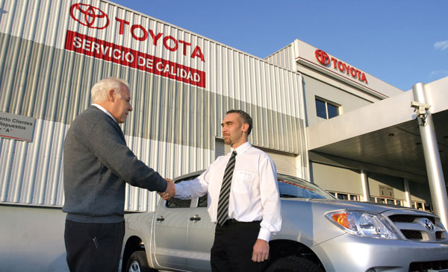Along with the implementation of the new Help Desk, **FullTech365’s** staff worked on the preparation of a knowledge database, where they’ll load every information related to common problems in the company. This database was growing as a result of daily work, and helped to reduce response times by more than 50%. The information contained therein can be largely avoided currently testing stage prior to the resolution, focusing the resource in the application of a well-known and documented solution, by itself or by their peers.

In addition, this database includes standard instructives for the use of the company standard tools, allowing in many cases to use them without incurring unnecessary resource unavailability.