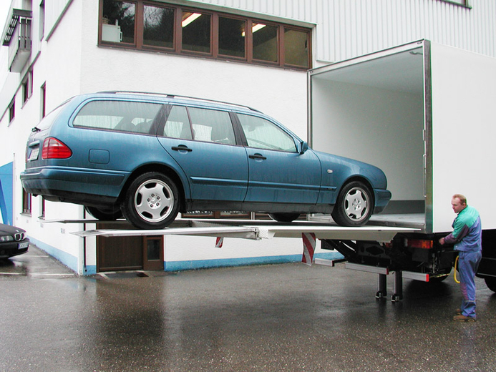



Comprehensive Solution: Zarate Industrial Plant activities start - Buenos Aires - Argentina

Dhollandia International wanted to install a commercial and industrial plant for first time in our country. For that, there was required a fast action and efficient response solution to complete the layout, supply and installation of all necessary infrastructure in the plant.

The top priority of our client lay in the need of being established on a very short term as an alternative in the market of lifts for trucks all across the country.

**Country:** Argentina

**Area:** Autoparts

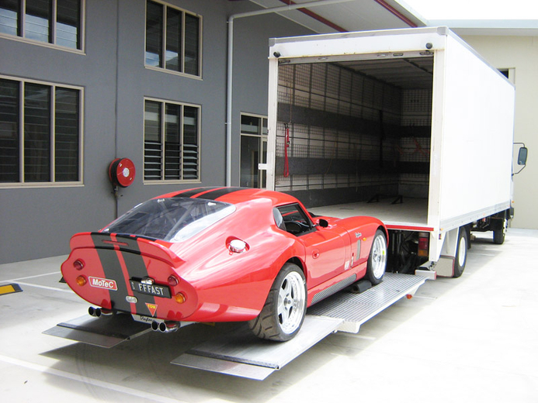**Client Profile: Dhollandia**is a Belgian auto parts company with presence in over 50 countries around the world. Its main business focuses on the manufacture, sale and installation of lifts for ground transportation, being the products and services offered by the companyof proven excellence, thanks to its long history.

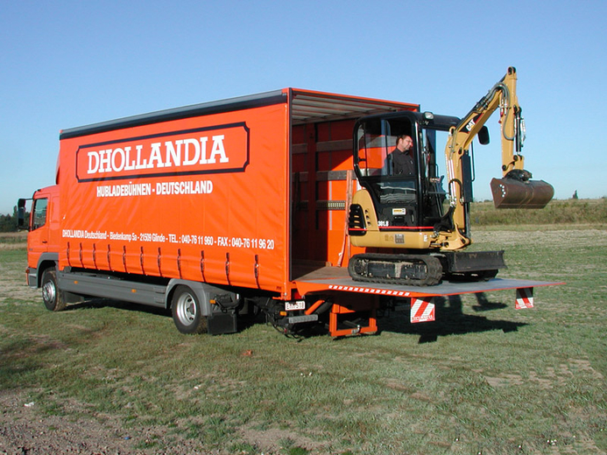

**The need of a fast response:**

When deciding the filing of the company in the country, **Dhollandia** encountered many barriers to overcome: the definition and installation of the entire network infrastructure of the plant and offices; provision, configuration and installation of necessary telecommunications equipment for the operation of such infrastructure and links with headquarters in Belgium;computers according **Dhollandia** standards; the subsequent provision of telecommunications services and the implementation of their whole systems.

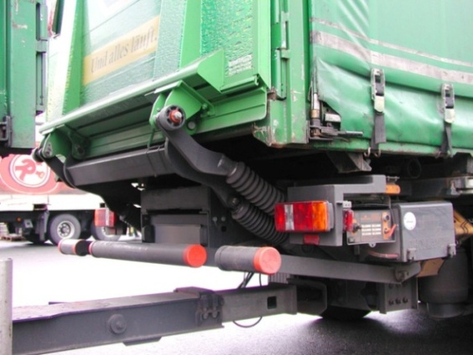Based on these needs, **FullTech365**, through one of its teams of specialists, relieved all the information and designed the necessary solution for the customer. As a first step, we worked on finding Internet and telephony services quotes in the area. We found this was a bounded offer, with inconsistent installation times and SLA's (those required were 99.6% service availability) far below the claims of the client. Finally, **FullTech365**obtained a personalized service by a third, according to the requirements mentioned above. Seeing the results, **Dhollandia** hired **FullTech365** as virtual partner for all their computer area requirements, entrusting the task to carry out in full, the commissioning of the new plant in Argentina. So **FullTech365** complete, fulfilling customer's urgency, the works of network cabling, provision and installation of user hardware and infrastructure, hiring telecommunications services through third parties, the configuration of all new equipment and, ultimately, successful connection with all **Dhollandia** Belgium systems.

**To provide an efficient and time according response to the customer;  
Two key points.**

Since the beginning of the project, **FullTech365** met the customer's need: receive a time sensitiveresponse to their requirements. When **Dhollandia**developed the project, they worked on an idea about offered services and response times by third party suppliers in the area that finally differed a bit of the real offer and times. Therefore, **FullTech365** acted as an intermediary, and conducted a search which ended with the development by one of these service providers of a personalized service, according Dhollandia global standards.

After defining the problem, **FullTech365**worked on all necessary aspects to achieve the response expected by the customer, obtaining maximum satisfaction for the success of the project. The performance of the professionals assigned to the project was flawless, what certainly defined the continuity of the company as Dhollandia virtual partner for all its computer area requirements.

***“When the project started, we found a totally different reality than we thought when defining the activities start time. The providers did not follow the schedule and we could see a significant delay in the onset of activity. With the help of FullTech365, we were able to be ready for the action before the original deadline.”***

**Javier Rolón Proietti  
Plant manager – Dhollandia Argentina**



As a consequence of the statement, **Dhollandia** could be ready for theirinsertion into the local market. The originally designed times were fulfilled to achieve real-time connection with their matrix (and, consequently, with all branches around the globe). This currently allows potential customers access all the information on products and services they need in a simple and effective way